Play 2 Clips
Season 4 Episode 2
In this scene, Jesus brings the disciples to Caesarea Philippi in the northern part of Israel, a place of awful pagan worship and rituals that we will discuss more later. It is here that Jesus will change Simon’s name to Peter.
Fact vs Fiction – In The Chosen story line, Jesus brought the disciples here during the period of mourning for the death of John the Baptist. In Scripture, it was after John’s death, but not necessarily during this period of mourning. So you will hear references in the clip to John, this is why.
Play clips: Skip ahead to 2nd scene with walking on trail; then skip once when Sanhedrin appear to next scene of Gates of Hell. (10 minutes)

The Passage
Let’s read the Scripture before diving in. Matthew 16:13-20
¹³ When Jesus came to the region of Caesarea Philippi, he asked his disciples, “Who do people say the Son of Man is?”
¹⁴ They replied, “Some say John the Baptist; others say Elijah; and still others, Jeremiah or one of the prophets.”
¹⁵ “But what about you?” he asked. “Who do you say I am?”
¹⁶ Simon Peter answered, “You are the Messiah, the Son of the living God.”
¹⁷ Jesus replied, “Blessed are you, Simon son of Jonah, for this was not revealed to you by flesh and blood, but by my Father in heaven. ¹⁸ And I tell you that you are Peter, and on this rock I will build my church, and the gates of Hades will not overcome it. ¹⁹ I will give you the keys of the kingdom of heaven; whatever you bind on earth will be bound in heaven, and whatever you loose on earth will be loosed in heaven.” ²⁰ Then he ordered his disciples not to tell anyone that he was the Messiah.

The Setting – “What is the Gates of Hell” at Caesarea Philippi?

Caesarea Philippi
- Named after Philip the Tetrarch who ruled this region. Philip is the half-brother of Herod Antipas (sons of Herod the Great)
  - Anyone recall what happened between Philip and Herod Antipas?
  - Herod Antipas Married Heroditas, the wife of Philip (stole her from him)
  - She is the one who requested the head of John the Baptist who criticized move
- Road to Damascus led through these valleys
- A spring flowed out of this dark cave and fed into the Jordan River
  - One of the headwaters.
  - Also 2 other springs and runoff from snow from Mt. Hermon.
  - Beautiful valley. Water still flows below today, but no longer out of this cave

Gates of Hell
The big dark cave with water flowing out of it was thought to be the gates to the underworld (Hades/Styx). This is where the pagans believed their gods would travel between worlds. They especially worshiped the god Pan here, a god who had a half human/half goat body. Pan was the god of the underworld and the god of nature (ever hear of pantheism?)
Massive temples here to Pan and to Zeus.
The pagans of Jesus' day commonly believed that their fertility gods lived in the underworld during the
winter & returned to earth each spring.
They saw water as a symbol of the underworld & thought that their gods traveled to & from that world through caves. To the pagan mind, then, the cave & spring water at Caesarea Philippi created a gate to the underworld. They believed that their city was literally at the gates of the underworld, the gates of hell. In order to entice the return of their god, Pan, each year, the people of Caesarea Philippi engaged in horrible deeds, including prostitution & sexual interaction between humans & goats.
What would the Jews have thought about this place?
Caesarea Philippi was like a red-light district in their world & devout Jews would have avoided any contact with the despicable acts committed there.
Not sure if they still did this during the time of Christ, but these temples had a history of child sacrifice as well as animal sacrifice. If the sacrifice sank, they believed the sacrifice was accepted by Pan. Otherwise, they felt it was rejected.
Also – prior to Pan, Baal was worshipped here, which involved child sacrifice; now Caesar was worshipped there, as evidenced by the name given to the place.
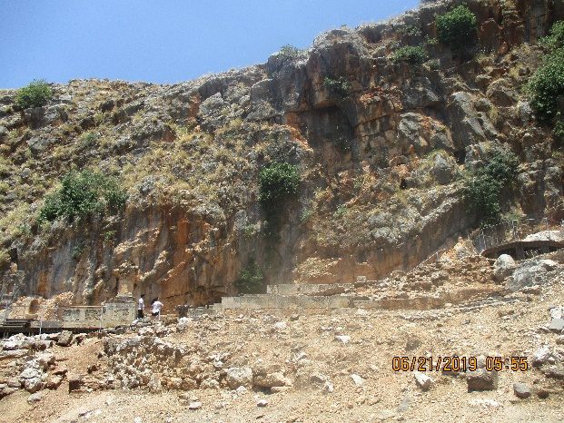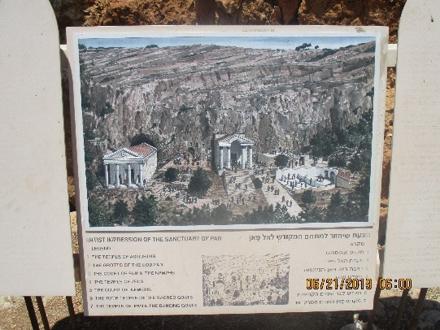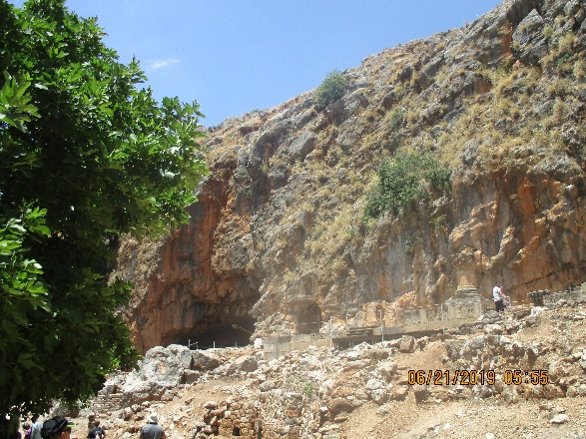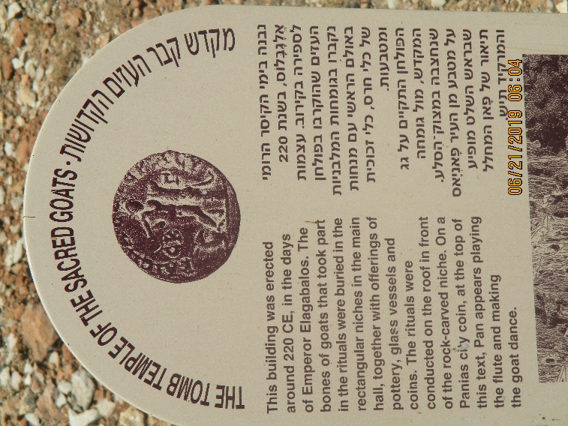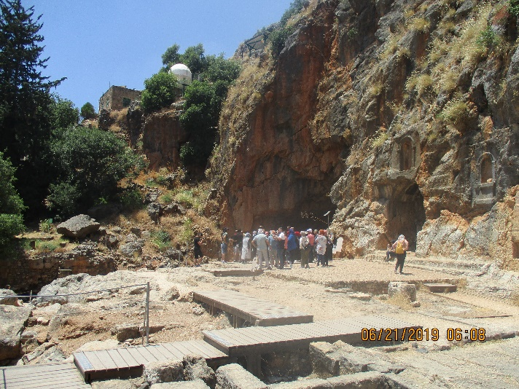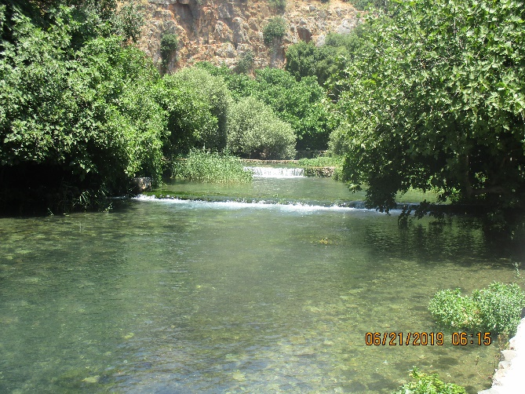

V13-14 – Who do people say that I, the Son of Man am?
“Who do people…” What people is he asking about? The common opinion, not Pharisees and priests
Some translations don’t include “I” in Jesus’s question, which would change the entire meaning of the question. Who do people think the Son of Man is vs Who do people think I am… I think Jesus was asking about people’s opinion of Him
… Either way, He used the phrase Son of Man
How did the disciples respond? What did the common man think about Jesus?
- John the Baptist
- Elijah
- Jeremiah
- One of the prophets
If Jesus had been one of these prophets, what would that have meant about him?
Raised from the dead
Would these have been bad things to think about someone? No, very honorable, yet they fall short of the mark; It is possible for men to have good thoughts about the Christ, yet not good enough.
If Jesus stood in front of us today and asked the same question – “who do people say that I am,” how would we respond to Him?

V 15-16 Who do you say that I am?
Why do you think Jesus took them to this place at this time to ask them this important question?
- Contrast to the evil around them at this pagan place
- Contrast to all the rejections he’d received lately
  - John the Baptist killed
  - People in his hometown rejecting him
  - Religious leaders opposing him
- Contrast to the people’s views in his first question, who believed him a prophet but not the Messiah
- Opportunity for the disciples to make a public profession of their faith
What thoughts do you have on Peter’s succinct answer in Scripture? How do you like the way Peter was depicted giving this answer in The Chosen?
- I like the word “living” in his answer. Jesus is the Son of the living God, in contrast to the death that surrounded them in this place.
If someone asks you who you think Jesus is, do you have an answer ready?

The Rock
Did you know that in reality, Simon was given the name Cephas before this? Or at least predicted that he would be given this name?
John 1: ⁴⁰ Andrew, Simon Peter’s brother, was one of the two who heard what John had said and who had followed Jesus. ⁴¹ The first thing Andrew did was to find his brother Simon and tell him, “We have found the Messiah” (that is, the Christ). ⁴² And he brought him to Jesus.
Jesus looked at him and said, “You are Simon son of John. You will be called Cephas” (which, when translated, is Peter).
However, I believe it was solidified here. And given special meaning. Now Catholics have taken that a step further, and used this as evidence that Peter was the first pope. They say that Jesus handed Peter the keys, giving him primacy over the other disciples. Your thoughts?
Peter believed in priesthood of all believers:
I Peter 2:9 – Peter himself writes about believers: “You are a chosen people, a royal priesthood.”
I Peter 2:5 – Peter encourages us to live like living stones, being built into a spiritual house to be a royal priesthood.
Peter was not infallible – He denied Christ
No mention of primacy of Peter - There is no mention in Acts or in Paul’s letters that Peter had primacy over all the other apostles.
So what is the significance of Peter’s name, and Jesus response to Peter’s declaration?
- Peter is a foundational piece of Christ’s Church
- The church is going to be granted the keys to overcome death and the powers of Hell
What challenge was Jesus giving to the disciples by bringing them to that place of death and corruption? What challenge is he giving to us today by this event?
- We are not called to hide from evil. We are to storm the gates of hell (gates are a defensive structure)
- Our church (the global church) is to stand against evil and overcome death through Jesus

